SHRM -- EMPLOYEE RELATIONS

Waving Goodbye to the Handshake: 7 Alternatives to a Workplace Custom

By John Egan April 27, 2020
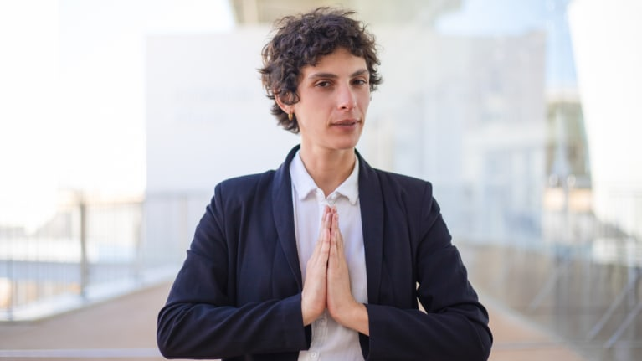
The time-honored handshake spreads goodwill in the workplace—in job interviews, at staff meetings and during other face-to-face interactions. But the handshake also spreads germs.
During the coronavirus pandemic, handshakes have given way to fist bumps, elbow taps and other greetings that eliminate hand-to-hand contact but don't necessarily decrease transmission risks associated with coronavirus. Once people start filtering back to workplaces in great numbers, will they shake hands again?
While the handshake probably won't disappear altogether, it likely will be pushed aside by other methods for people to acknowledge each other. Dr. Anthony Fauci, the director of the National Institute of Allergy and Infectious Diseases and a leader in the fight against the pandemic, advocates an end to the practice of shaking hands to reduce transmission of the coronavirus and other germs. Years ago, President Donald Trump, a self-proclaimed germaphobe, called in one of his books for the disappearance of the handshake.
So, if the traditional handshake loses its place in the workplace—either temporarily or permanently—what are the alternatives? Here are seven possibilities.
Offer a Nod and a Smile
Tiara Gazarian is director of sales and client relations at Glendale, Calif.-based Phonexa, which provides software to track online and telephone marketing campaigns. For Gazarian and other salespeople, the handshake is a conventional go-to icebreaker.
To sidestep fears about the coronavirus, Gazarian envisions replacing the handshake with a head nod accompanied by a "genuine" smile as a way to acknowledge and welcome somebody while maintaining a safe physical distance.
"How genuine the smile is will make all the difference—it's about letting the person know that you are truly interested in meeting them and hearing what they have to say," Gazarian said.
Take a 'Dip'
Yaniv Masjedi, chief marketing officer at Nextiva, a Scottsdale, Ariz.-based provider of communications software, recommends a "head dip" as the "new" handshake. It's essentially a more subtle version of a head nod.
"Honestly, a lot of people are great at this already. It would be the same knowing head nod you do with friends across a room—an acknowledgement that you saw each other but no more than that," Masjedi said. "As a greeting and a goodbye, I think it would be a great alternative in both business and personal settings. And much less awkward than a close-proximity wave."
Make a Good First Impression
Chris Vennitti, Mid-Atlantic president of Chicago-based staffing firm Addison Group, said that well before the coronavirus pandemic, physical contact like handshakes or hugs was "confusing and awkward." People were uncertain what was appropriate or safe in a professional setting, he said.
Nowadays, a head nod, smile or brief wave can be effective substitutes when introducing yourself during a virtual or in-person job interview or at a meeting, Vennitti said.
"Making a good first impression matters far more than the handshake itself. When introducing yourself, make it clear that you're happy to meet the person and grateful for the opportunity at hand," he said. "Whatever you do, be authentic and do it with a smile."
Being prepared, pleasant and conversational packs more of a punch than being able to deliver a firm handshake, Vennitti said.
Develop a Workplace Code
Patricia Sharkey, the Ontario, Calif.-based chief people officer at IT staffing company IMI People, doesn't think we'll entirely shake our handshake habit.
"From an HR standpoint, we are continuing to look for tangible, authentic and professionally appropriate methods to connect," Sharkey said. "Taking the handshake out of the workplace leaves the company one less instrument to welcome and engage with the team."
Nonetheless, if your workplace decides to ditch the handshake, there are other ways to engage. Among Sharkey's recommendations: Create a companywide germ-free greeting. This could be a unique code word or a physical gesture.
"It could turn into an engaging team development project to create the applicable verbal-only welcome or gesture," she said.
So that job candidates, clients and vendors feel comfortable in your organization's culture, she recommends introducing them to your special code or gesture.
Take a Bow
Jack Wang, who splits his time between New Jersey and China, handles hiring as CEO of AmazingBeautyHair, an online seller of hair extensions. He figures it might be months or years after the pandemic ends before the handshake makes a return. Even then, he said, strangers might not press the flesh at all.
In the meantime, Wang votes for the Japanese bow as a handshake alternative.
"It's subtle, it's not that flamboyant and it is already generally understood," Wang said.
Go for 'Namaste'
If you've ever practiced yoga, you're familiar with the "namaste" gesture.
In a recent opinion piece published by The Washington Post, John-Clark Levin, a Ph.D. candidate in politics and international studies at the University of Cambridge, made the case for this age-old Hindu gesture as a handshake substitute. The gesture involves pressing your palms and fingers together at your chest while bowing slightly.
Even absent of simultaneously uttering the word "namaste," this gesture "communicates goodwill without any handshake-like undertones of status or dominance," Levin wrote. "It signals purpose and self-mastery; no need to worry that anyone is judging the quality of the execution."
Surabhi Lai, chief impact officer at Luminary, a New York City co-working and collaboration hub geared toward women, maintains that the "namaste" gesture is more graceful than a handshake and just as professional.
Focus on Eye Contact
Callista Gould, a certified etiquette instructor who founded the Culture and Manners Institute in West Des Moines, Iowa, believes that although the handshake might take a sabbatical because of the coronavirus pandemic, it will ultimately survive.
"Until then, smile, make eye contact and bow slightly to acknowledge the other person," said Gould, author of The Exceptional Professional: What You Need to Grow Your Career (Keller, Burns, and McGuirk, 2018). "In the absence of the handshake, connecting with our eyes will become more important—with allowances for cultural differences in eye contact, of course."
John Egan is a freelance writer based in Austin, Texas.

